**Support Vector Machine (SVM) Classifier**

Machine learning algo in which we are working in vector space.

Complex.

**Binary classifier:** Separates only into two groups at a time (+ and -)

**Objective:** To find the best separating hyperplane also referred to as decision boundary.

Green line is the best separating hyperplane. The distance of the perpendicular bisector of the hyperplane must be the greatest to the associated data points for the hyperplane to be the best separating hyperplane.

The purple line is also a hyperplane but the distances between its perpendicular bisector to the associated data points are not the greatest possible so it is not the best separating hyperplane.

After finding the best separating hyperplane, we can take unknown data points. If a point lies on the right of the best separating hyperplane it is a positive sample and if it lies on the left it is a negative sample.

Since SVM is a binary classifier, we need to have linear data to use it. If data is non-linear then we can’t find the best separating hyperplane. Below is an example of data points where we can’t find the best separating hyperplane.

**Understanding Vectors:** Direction and Magnitude

Dot Product A.B

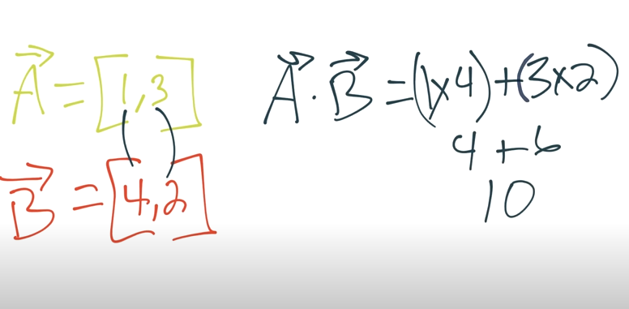

**Support Vector Assertion**

‘W’ is a vector pointing towards the decision boundary (best separating hyperplane) and is perpendicular to the decision boundary. W is used to determine whether an unknown point ‘U’ is on the right hand (+) side of the decision boundary or the left hand side (-). For this we project ‘U’ onto ‘W’ using the formula U.W + b. If U.W + b is greater than or equal to 0 then ‘U’ is on the right side (+) else it is on the left side (-). If U.W + b = 0 then ‘U’ is on the decision boundary.

**Finding ‘W’ and ‘b’: (b = bias)**

We know that the unknown ‘U’ is any input point (x1,y1). We must first know what the values for ‘W’ and ‘b’ are to find the solution to the equation U.W + b.

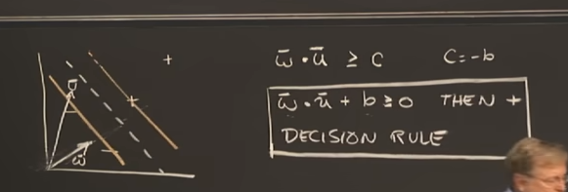

to calculate ‘W’ and ‘b’, we have to put a constraint.

Let’s assume that the unknown ‘u’ is some positive point then the result of the equation U.W + b will be 1 or greater than 1 as shown in the image above. Vice-versa if ‘u’ is some negative point.

Introducing a new quantity – Ysub_i for mathematical convenience

Multiplying both equations by Ysub_i (both equations become the same)

Gutters: Line on closest positive and negative samples. Our aim is to find the decision boundary so that the perpendicular line to the decision boundary separating the two gutters is as wide as possible.

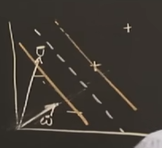

(yellow lines are the two gutters, white dotted line is the decision boundary. Gutters must be as wide as possible to the decision boundary)

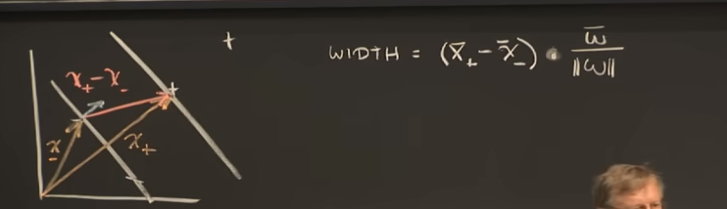

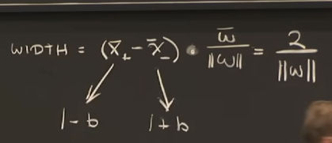

If X is a positive sample we get 1 - b and if X is a negative sample we get 1 + b using the equation below by subbing +1 and -1 in place of y and getting the values for +X.W and -X.W

By further simplifying we get 2/||W|| as 1 + b and 1 – b equals 2.

So width of the street is 2/||W|| (2 over magnitude of W)

**To maximize the distance:** To maximize the distance 2/||W||, it is okay to maximize 1/||W|| and for that we have to minimize ||W|| and to minimize ||W|| it is okay to minimize ½||W||^2 as it is mathematically convenient.

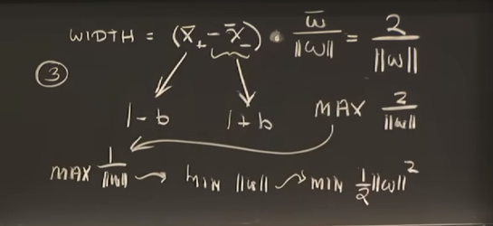

Therefore, to get maximum width we have to minimize ½||W||^2

**Lagrange:**

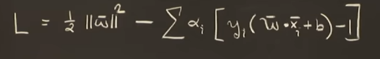

L = ½||W||^2 – summation of all the constraints

**Derivative of L with respect to W:**

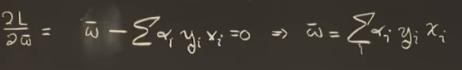

We put the derivative equal to 0 because we are finding extrema points (max or min) and at those points derivative = 0 and by that equation we can get the value of W.

**Derivative of L with respect to b:**

**Subbing in the value of W in the original expression of L:**

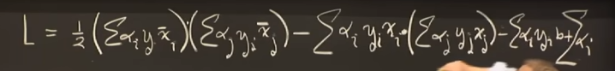

**Simplifying:**

**So finally subbing in the value of W in the decision rule**

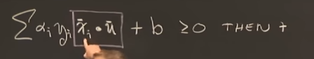

So what we can conclude from this is that the decision rule is totally dependent on the dot product of vector X and unknown vector U.

**Support Vector Machine Optimization**

**Formula for classification of feature set**

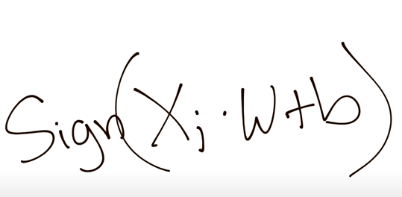

Classification is easy once we optimize for what W and b are.

**Two Main Optimization Objectives:**

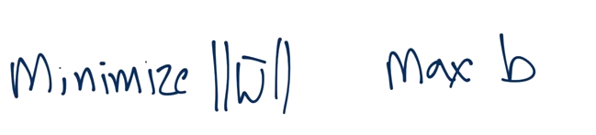

<https://www.youtube.com/watch?v=bGCafQT5h1s&list=PLQVvvaa0QuDfKTOs3Keq_kaG2P55YRn5v&index=24> Watch from (8:30 onwards)

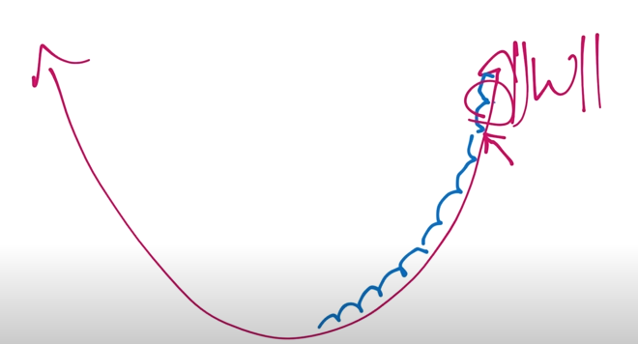

The SVM is a Convext Optimization Problem and Python has several modules as shown in the image below to solve this problem. We will be using the logic explain in the video in above link instead to build the SVM by hand and won’t be using these modules currently as we are in learning phase.

